Mathematics — 2006 (Set III — Outside Delhi)
SECTION – A
Q. 1. If 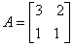, find the values of a and b such that A² + Aa + bi = 0. Hence find A⁻¹.
Q. 2. Using properties of determinants, prove the following:
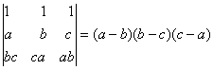
Q. 3. Solve the following differential equation:
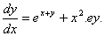
Q. 4. 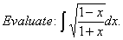

Q. 9. Differentiate from first principle.
Q. 10. 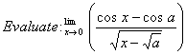
Q. 11. Verify Lagrange’s Mean Value Theorem for the following:
Q. 17. Using matrices, solve the following system of equations:
